
Essentials Mathematics Test #8

60
Topics – Statistics & Data

Name

- Attempt all questions
- Show all working and calculations where possible
- Calculators are allowed
- One A4 page of notes is allowed

You must include all working out to receive full marks

Question 1 (10 marks)
From the list of data displays below, choose the most appropriate way to display the data described in each part below and explain the reasons for you choice.
- Column graph
- Dot frequency diagram
- Back to back stem and leaf diagram
- Histogram

- The heights (measured in cm) of 20 boys and 20 girls to compare them.

- The eye colour of all Year 11 students.

- The foot length, measured in cm, of the members of your class.

- The percentage of students in each year at our school.

- The heights, measured in cm, of all Essentials students.

Question 2 (5 marks)
This dot plot shows the foot length of a group of students.
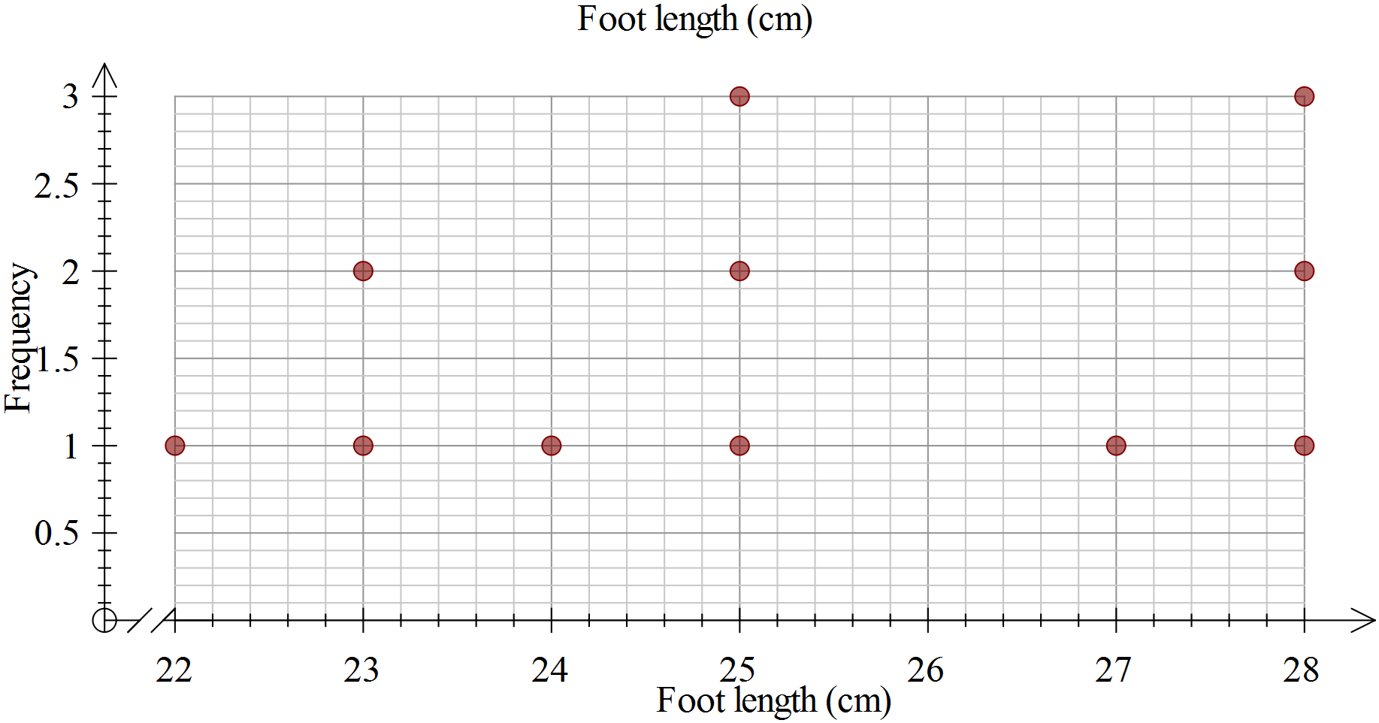
- Calculate the range of the scores, showing your working.

- Determine the mode.

- Determine the median.

- Calculate the mean, showing your working.

- Complete this sentence: For a student in this group, you would expect them to

have a foot length of about ______cm.

Question 3 (3 marks)
Two classes are marked on the same tests.
Class P has a mean of 65% and standard deviation of 5.
Class Q has a mean of 50% and standard deviation of 15.
- Write a statement comparing the scores of the two classes, that is who had the better scores?

- Write a statement comparing the spread of the scores for the two classes.

- Which class would you expect to have the highest score? Explain.

Question 4 (20 marks – 2, 8, 6, 4)
Height (cm)
Year 7 students
Female | Male
106 | 141
142 | 142
143 | 148
144 | 148
147 | 149
147 | 149
152 | 150
152 | 150
153 | 154
153 | 154
155 | 156
155 | 156
157 | 157
160 | 158
162 | 159
164 | 164
165 | 165
170 | 169
172 | 170
176 | 170
Consider the data to the right, showing the heights of 20 male and 20 female Year 7 students, taken from CensusAtSchool.
- Circle or highlight any outliers in the data.
For any you find, explain why you consider it an outlier.

- Use the grid paper provided to make a back-to-back stem and leaf diagram to display this data.

- Complete the table below, showing your working, to summarize the statistics for this data.

Statistic | Female | Male
Mode
Median
Range

- Using your stem and leaf plot and/or the table in c), compare the data for males and females.
In what ways are the two groups similar?

In what ways are the two groups different?

Question 5 (22 marks-2, 10 ,4 , 6)
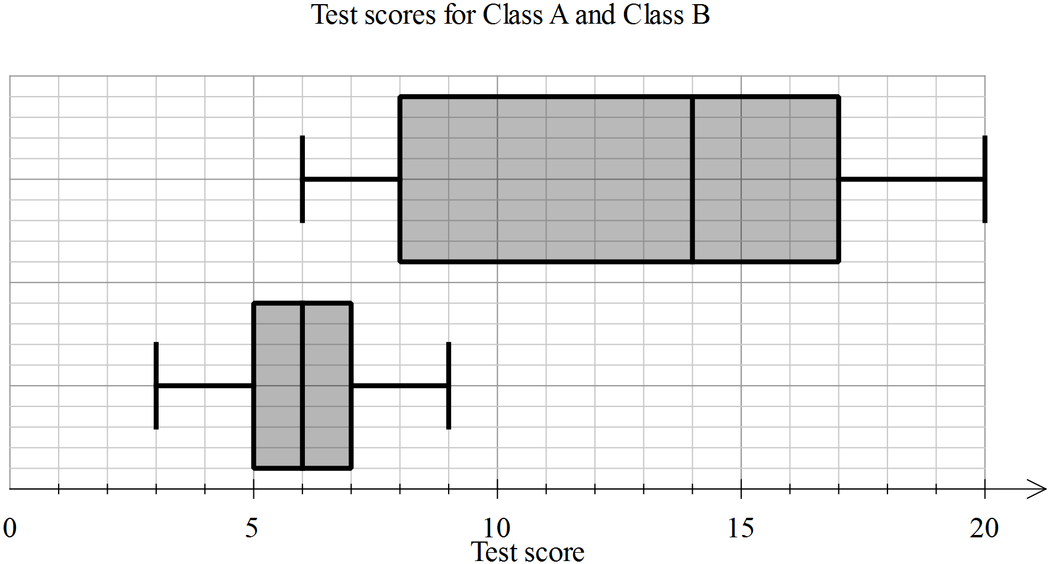
- Eric is in Class A, he scored 5 on the test. Label the two box plots with their class names.
- Use the table below to enter the appropriate values for each of the plots.
Statistic | Class A | Class B
Minimum
First quartile
Median
Third quartile
Maximum

Calculate the range and interquartile range for each class, showing the working, in the table below.

Statistic | Class A | Class B
Range
Interquartile range

- In each of the statements below, write A and B as appropriate to make the statement true.
- Class ___ has a much greater range than Class ___
- The minimum for Class ___ is the same as the median for Class ___
- For Class ___, the second and third quartiles are the same width, whereas for Class ___, the second quartile is much greater than the third quartile.

END OF TEST

